Tennessee Military
Department

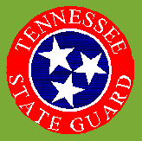

BASIC MILITARY
ORIENTATION

FOR

in

Montgomery Co
Houston Co
Stewart Co
Robertson Co
Dickson Co
Cheatham Co
TENNESSEE STATE GUARD
204th Infantry Battalion, Second Infantry Brigade Edward Norman Armory 1801 Fort Campbell Boulevard Clarksville, Tennessee 37042-5109

1 Nov 2002
500/S1/RG

From: To:
Commanding Officer Newly Joined Personnel

Subject:

ORIENTATION

References:

(a) TNSG Reg 10-1 Organization and Function
(b) TNSG 350-1 Operations and Training
( c) TNSG 600-10 Personnel and Admin Procedures (d) TNSG 670-1 Uniforms
(e) TNSG 672-5-1 Decorations and Awards

Welcome to the 204th Infantry Battalion of the Tennessee State Guard. We hope your time spent with us will be rewarding. We are aware that some new joins have no military background and others have been out for a long time. This packages was created using references (a) through (e) to orientate anyone to the basic regulations, military terms and procedures of the Guard.

The 204th's area of operations (AO) consists of Montgomery County where the Headquarters ofthe Battalion and A Company are co-located. Dickson County is home to B Company, Robertson County is home to C Company, Houston and Stewart Counties is home to D Company and Cheatham County is home to E Company. Not all our Companies are staffed at this time but as recruiting increases our numbers those companies will stand up again.

People confuse the State Guard with the National Guard. The difference is, the State Guard is an all-volunteer organization of the Tennessee Department of the Military, (www.tnmilitarv.org) and cannot be used out of the state. Under the direction of the Governor, the State Guard is prepared to replace deployed National Guard units, become custodians of vacated armories and any equipment left behind in the event of National Guards mobilization. Additionally we are prepared to augment the National Guard and the Tennessee Emergency Management Agency in cases of natural or technological disasters and in matters of homeland security. We are also members each armories Family Readiness Group, prepared to assist family members of those deployed guardsmen. Most people see us while training, at public parades, ceremonies, military funerals or teaching classes in CPR. 1st Aid and or disaster preparedness.

Here at the 204th we have a agreement with the American Red Cross to provide security during shelter operations or
during times of heighten awareness. Additionally we are a force amplifier for the Emergency management Director of Houston County for search & rescue operations, or when the county EOC is opened. These are voluntary duties and not a State Guard requirement. Our duties as a State Guardsmen take priority over any of these missions.

On behalf of the Commander, we wish to express our appreciation for joining us in our endeavor to assist our state and communities when needed.

FOR THE COMMANDER
1. Encl: Orientation Pamnhlet.
C. L. STOUT
CW03 TNSG Operations officer (S-3)

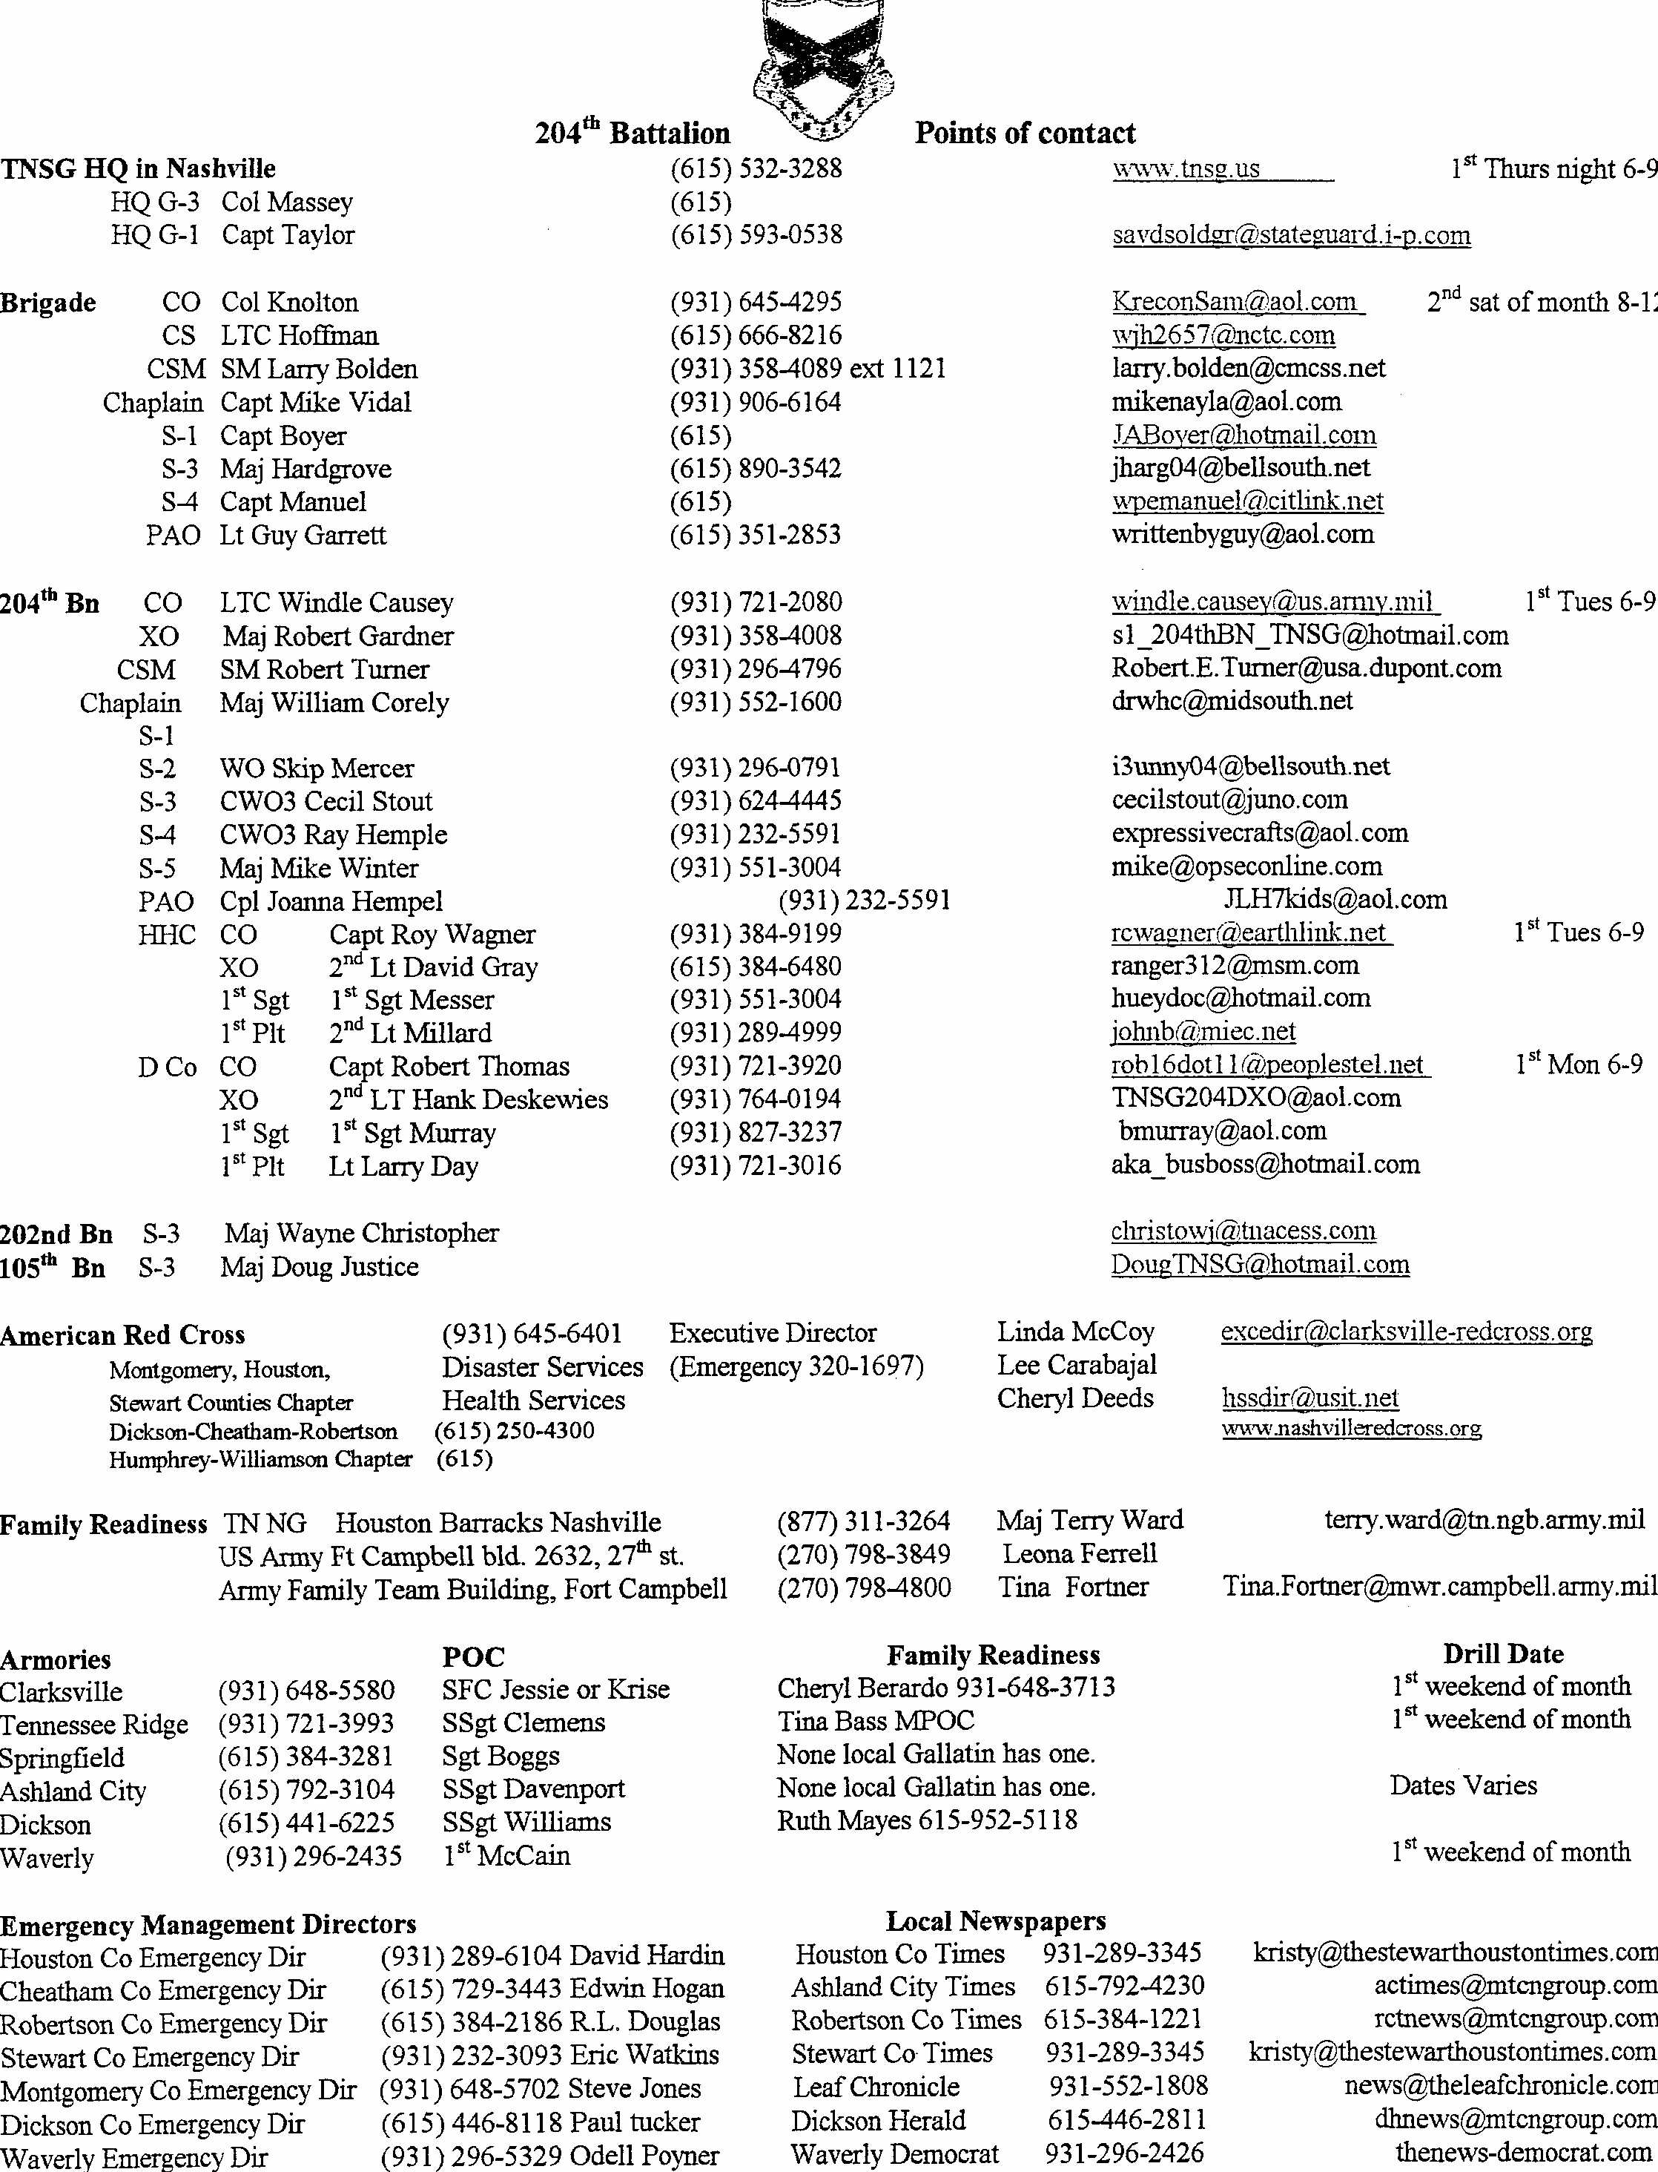

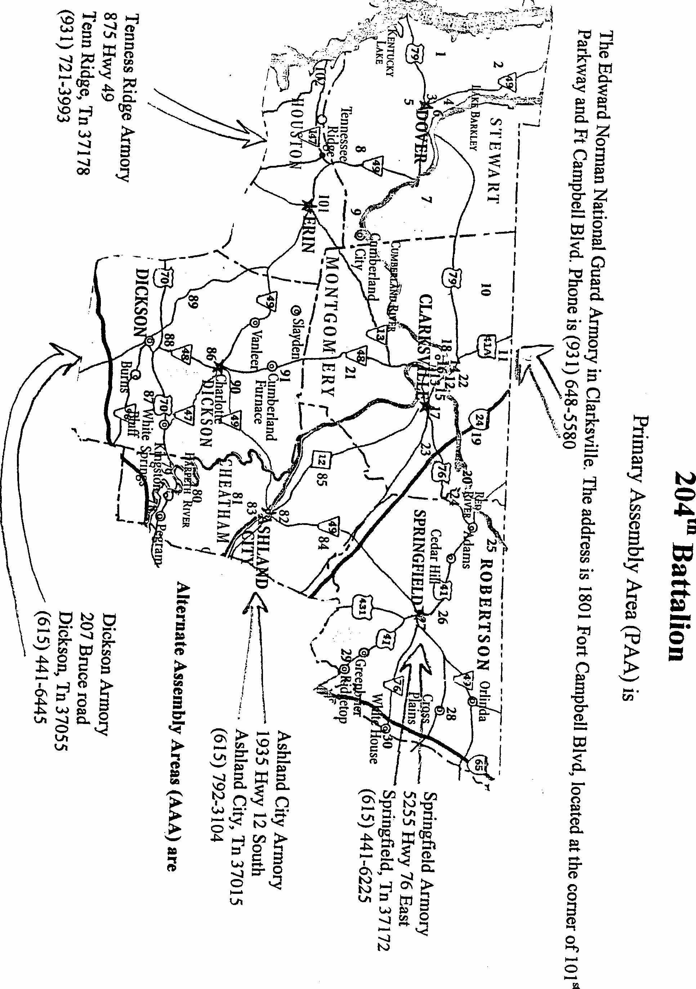

MISSION OF THE TENNESSEE STATE GUARD

The mission, of the Tennessee State Guard is to provide an adequately trained force capable of providing an organized state military reserve force under gubernatorial control, which in addition could accomplish those state emergency responsibilities normally assigned to the National Guard, when that force is federalized or otherwise not available, or adequate to the needs of the governor. Typical missions include:

(1) Assist civil authorities in the preservation of order and protection of life and
property.

(2) Meet such domestic emergencies as may arise within the state.

(3) Guard and protect critical industries, installations, and facilities when other means such as local police or privately owned protection are deemed inadequate.

(4) Prevent or suppress subversive activities in conjunction with or in support of state
and local/law enforcement agencies.

(5) Under control of the Governor, cooperate and coordinate with federal military authorities and forces engaged in active military operations or charged with internal security missions within the state.

(6) Cooperate with federal military authorities in information and observation duties, and in extreme emergencies, assist in the evacuation of civilians.

(7) Assume control of state armories, provide security of equipment, and assist in mobilization of the National Guard and provide Family Assistance, when directed by the Governor.

(8) Perform such other duties as may be assigned by the Governor under the
constitution and laws of the state.

SECTION I

Tennessee Military Department

TENNESSEE MILITARY DEPARTMENT

The volunteer spirit and Tennessee, an inseparable combination since 1780 when Colonel John Sevier called for "100 good en" --and 200 answered--has been a source of pride for generations of Tennesseans. Today that spirit is still alive and well with the Tennessee Army and Air National Guard. They serve as full partners with active duty American men and women, worldwide to make up the "Total force" of American defense. Nationwide, the Army National Guard contributes more than half of the Army's total combat strength for about nine percent of the total budget. The air National Guard performs about 35 percent of the total Air force mission for about six percent of the entire annual Air force budget. America simply cannot defend herself or go to war without the National Guard

History
The official military history of the state of Tennessee dates to June 1, 1796 when President George Washington signed the act of Congress admitting Tennessee as the 16th state.
An act of the 45th General Assembly in 1887 created the military organization known as the Tennessee National Guard. Nations and governments are created by deeds of men. The act of 1887, which set up the basic conditions under which the military arm of Tennessee has operated, followed more than a century of deeds that set the standards the Tennessee National Guard looks to with pride.

Early Military History
In 1774, militias were formed in the areas of Sullivan and Carter counties, to face a threat from the Shawnee Indians. The militia and Indians fought a decisive battle Point Pleasant (Kenawa).
John Sevier and Issac Shelby in 1780 led mounted Tennessee riflemen to another decisive battle, Kings Mountain. With the fledgling United States in the throes of a revolutionary war, Sevier and Tennessee Militiamen fought Hessian mercenaries and British regulars and won the battle considered the turning point of the war in the southern states.

The Indian Wars and the War of 1812
As Tennesseans pushed west and south toward the Tennessee River, however, they began to press upon Creek territory and hostilities resumed The Creeks were the most formidable tribe on the Tennessee borders, and they were widely believed to be under the influence of belligerent British and Spanish agents. In 1812, moreover ominous rumors reached the frontier of a warlike confederacy of the Ohio Valley tribes led by Tecumseh and his brother, the Prophet. Tecumseh had visited the Creek Nation the year before to urge the southern tribesmen to join his warrior crusade to roll back white settlement. His prophecy that the earth would tremble as a sign of the impending struggle was seemingly confirmed by a series of massive earthquakes, which convulsed western Tennessee and created Reelfoot Lake. Anti-British sentiment ran high in Tennessee, and Tennesseans were easily disposed to link the Indian threat with British outrages on the high seas. Led by Felix Grundy of Nashville the state's representatives were prominent among those 'War Hawks" in Congress who clamored for war with Great Britain. When war was declared in June 1812 (with the unanimous assent of Tennessee's delegation), Tennesseans saw an opportunity to rid their borders once and for all of Indians. Their chance came soon enough. News reached Nashville in August 1813 of the massacre of some 250 men, women and children at Fort Mims, Alabama. Tecumseh's message had taken hold, and the Creek Nation was split by civil war. The Fort Mims attack was carried out by the war faction, called Red Sticks, under their chief, William Weatherford. Governor Willie Blount immediately called out 2,500 volunteers and placed them under the command of Andrew Jackson. Jackson' s 1813 -1814 campaign against Weatherford's warriors, known as the Creek War, really constituted the Southern phase of the War of 1812. Despite a chronic shortage of supplies, lack of support from the War Department, and mutiny Jackson's militia army prevailed in a series of lopsided victories over the Red Sticks. His victory at the Battle of Tohopeka (Horseshoe Bend) utterly destroyed Creek military power and propelled not only Jackson, but also his lieutenants William Carroll and Sam Houston, to national prominence. On the heels of his success against the Indians, Andrew Jackson was appointed major general in the U. S. Army and given command of the Southern military district just in time to meet an impending British invasion of the Gulf Coast. Having secured Mobile and driven the British out of Pensacola, Jackson hurriedly marched his troops to New Orleans to rendezvous with other Tennessee units converging for a defense of the city. On January 8 1815, Jackson's ragtag troops inflicted a crushing defeat on a veteran British army under Sir Edward Pakenham, who was killed along with hundreds of his soldiers. The Americans lost 23 dead. Despite having occurred fifteen days after the signing of the peace treaty with Great Britain, the Battle of New Orleans was a brilliant victory (one of the few unequivocal American successes of the war), and it launched Andrew Jackson on the road to the presidency. Three years later he led yet another force composed largely of Tennesseans into Florida in an action supposedly directed against the Seminoles, but one that convinced Spain to cede Florida to the United States.

The Mexican War
When a Tennessean, President James K. Polk, issued an immediate call for 50,000 volunteers, nationwide, to fight in the war with Mexico, Tennessee met its quota of 2,600 with 26,000 volunteers. A lottery was established to determine which Tennesseans would be allowed to serve.

The American Civil War
Tennesseans were involved on both sides of the American Civil War as brother fought brother, and father fought son. A unique and tragic period in the history of the Tennessee Military, space here does not allow us to elaborate on the profound effect this conflict had on the Volunteer State. More information can be found in our "Tennesseans During the Civil War" page.

World War I
During World War 1, the 30th (Old Hickory) Division from Tennessee helped smash the Hindenburg Line, the strongest defensive system devised to that date.

World War II
In World War 11, the German High Command regarded the 30th Division as "Roosevelt's Shock Troops."

DESERT STORM
Some 3,600 men and women of the Tennessee National Guard, both Army and Air, were called to active duty during Operations Desert Shield and Storm. The 130th Rear Area Operations Center from Smyrna and the 176th Maintenance Battalion Headquarters from Johnson City were among the first Tennessee units called to active duty. Other Army National Guard units called to support Operation Desert Storm were: 776th Maintenance Company, Elizabethton 1175th Quartermaster Company, Carthage 251st Supply and Service Company, Lewisburg 212th Engineer Company, Tracy City 11 74th Transportation Company, Dresden, 663rd Medical Detachment, Smyrna 268th Military Police Company, Ripley 300th Mobile Army Surgical Hospital, Smryna 775th Engineer Company, Camden 155th Engineer Company, Waverly Headquarters, 196th Field Artillery Brigade, Chattanooga 18 1 st Field Artillery Battalion, Chattanooga 269th Military Police Company, Dyersburg I I 8th Public Affairs Detachment, Nashville 568th Personnel Service Company, Smyrna 213th Health Services Liaison Detachment, Smyrna. Air National Guard units that deployed were: 134th Air Refueling Group, Knoxville 118th Tactical Hospital, Nashville 164th Tactical Clinic, Memphis 134th Services Squadron, Knoxville 164th Mobile Aerial Port Squadron, Memphis 118th Aeromedical Evacuation Flight, Nashville. The Tennessee Army National Guard has participated in every principal war in which America has been engaged. These brave Americans are truly "The Pride of Tennessee".

War on Terrorism
The Tennessee National Guard has been extremely active since the terrorist attacks on the World Trade Center and the Pentagon on September 11, 2001. The 134th Air Refueling Wing flew on September 11th refueling fighter and CAP aircraft throughout the east coast. The 164th ALW Deployed 4-aircraft within 20 hrs. The 118th ALW Deployed 110 personnel within 22 hours. The 228th Combat Comm. Deployed to Quatar to provide combat communications to American forces deployed in the Middle East. As of December 2002, more than 822 Tennessee Air Guard Troops have mobilized since 9/11. One Hundred and three Army Guard Soldiers deployed to provide security at 6 Tennessee Airports from October 2001 to June 2002. Eighty plus soldiers from the 168th Military Police Company in Ripley and Dyersburg deployed as additional security at Milan Arsenal and the Holston Army Ammunition Plant. More than 40 soldiers provided additional security at the Tennessee State Capitol & Legislative Plaza. In total, more than 1,000 Army Guard Soldiers have deployed in support of Operations Noble Eagle and Enduring Freedom. These soldiers and airmen work hand in hand with their active duty counterparts providing security for Tennessee and the United States of America. the present time. State emergency duty would involve protecting the lives and property of our citizens in the event of a natural disaster, man made disaster, civil disturbances and maintenance of law and order. The Tennessee State Guard could also be used to augment the National Guard or assist the Tennessee Emergency Management Agency.

WHAT IS THE TENNESSEE STATE GUARD?
The Tennessee State Guard was organized under Chapter 36 of the Tennessee Acts of 1985. By this enactment, the state Legislature reorganized the old Tennessee Defense
Force, which had been formed in 1941 but became inactive after 1946. The Tennessee State Guard is a volunteer force whose members receive no regular compensation for their service unless called to duty by the governor, at which time they receive regular mil~tary pay relative to their equivalent military rank and grade. Any citizen who is a
resident of the State of Tennessee, male or female, over age 17 and not older than age 67 (at time of entrance) may serve in the Guard. Members take an induction oath and are expected to attend a two hour drill meeting once a month, and a weekend training exercise once a year. There are approximately 1,000 members formed into four brigades which are headquartered in Knoxville, Chattanooga, Smyrna, and Jackson. The State Guard headquarters is located in Nashville.
Simply put ... The Tennessee State Guard is to the Tennessee National Guard what our National Guard is to the United States Army. It is an all volunteer organization that is a part of the Tennessee Military Department. It has no federal mission, being responsible only to the Governor of our state and the orders of the Adjutant General of Tennessee. Since all National Guard units are now affiliated with our regular forces, a
call up by the president of any or all of our National Guard forces would leave the governor with no military force at his disposal either in a specific area of the state or state wide.

The mission of the Tennessee State Guard is then, to replace these units, and become the custodians of the vacated armories, military facilities and equipment left behind by these departing units. In addition, the Tennessee State Guard would respond to any call by the governor for emergency state duty in the same manner the National Guard does at the present time. State emergency duty would involve protecting the lives and property of our citizens in the event of a natural disaster, man made disaster, civil disturbances and maintenance of law and order. The Tennessee State Guard could also be used to augment the National Guard or assist the Tennessee Emergency Management Agency.

TNSG ORGANIZATIONAL STRUCTURE

The Tennessee State Guard is organized as a light Infantry Division composed of
four (4) Brigades.

STATE GUARD HEADQUARTERS
NASHVlLLE, TENNESSEE
HOUSTON BARRACKS'

1ST BRIGADE HQ - JACKSON, TN

WITH UNITS IN - ALAMO, BOLIVAR, BROWNSVILLE, CAMDEN COVINGTON, DRESDEN, DYERS BURG, HENDERSON, HUMBOLT
HUNTINGDON, LAVINA, LEXINGTON, MEMPHIS, MARTIN
MCKENZIE, :MILAN, MILLINGTON, NEWBERN, PARIS, PARSONS, RILEY, SAVANNAH, SELMER, SOMERVILLE, TRENTON, UNION CITY

2ND BDE HQ - SMYRNA, TN

WITH UNITS IN - ASHLAND CITY, CARTHAGE, CENTERVILLE CLARKSVILLE, COLUMBIA, COOKEVILLE, CROSSVILLE, DICKSON, ERIN GALLATIN, HOHENWALD, JAMESTOWN, LAWRENCEBURG, LEBANON, LEWISBURG, LINDEN, LIVINGSTON, MURFREESBORO, PULASKI SMITHVILLE, SPRINGFIELD, WAVERLY, WAYNESBORO

3RD BDE HQ - KNOXVILLE, TN

WITH UNITS IN - ALCOA, BRISTOL, CLINTON, ELIZABETHTON, ERWIN, GREENVILLE, HARRIMAN, JACKSBORO, JONESBORO JOHNSON CITY, KINGS PORT, KODAK, LENOIR CITY, MARYVILLE MORRISTOWN, MOUNTAIN CITY, NEWPORT, NEW TAZEWELL OAK RIDGE, ONEIDA, ROGERVILLE, ROCKWOOD, SWEETWATER

4TH BDE HQ - CHATTANOOGA, TN

WITH UNITS IN - ATHENS, BENTON, CLEVELAND, DAYTON DUNLAP, FA YETTVILLE, MCMINNVILLE, MONTEAGLE, SHELBYVILLE SOUTH PITTSBURG, SPARTA, TULLAHOMA, WINCHESTER
SECTION I

THUMBNAIL SKETCH OF THE HISTORY OF THE STATE GUARD/TENNESSEE DEFENSE FORCE

"The sure and certain defense force of a free people is a well regulated state militia." Constitution of the State of Tennessee, Article I, Section, 24.

REVOLUTIONARY WAR: Four hundred volunteers from Sullivan and Washington Counties, (TN), then in North Carolina, under the leadership of Colonel Isaac Shelby and Major Charles Robertson crossed the mountains and helped defeat the British Troops. The British Commander, Major Ferguson, threatened these Tennessee factions by stating "If you don't desist, I will lay waste by fire and sword to the settlements. This raised over 1000 volunteers on 7 October 1780 and helped defeat the British at King's Mountain, just south of the North Carolina/South Carolina border. When North Carolina seceded the Tennessee Territory to the Federal Government on 2 April 1790, though not yet a state, it later came under the National Militia Act of 1792 and again in January of 1796. The need for a Militia was brought up at the Constitutional Convention showing a white population of over 600,000 at that time. The Militia Act stated that white males at the age of 18 be enlisted into the Militia.

WAR WITH CREEK INDIANS WITH ANDY JACKSON and THE WAR OF 1812: Tennessee volunteers fought against the Creek Indians and were a part of an abortive invasion of Canada during the War of 1812. Without waiting for federal authorization or direction, the State Legislature called for 3,500 volunteers. Recruitment was so enthusiastic that the term 'Volunteer State" was first used. The Militia and other Tennessee volunteers engaged the British along the Gulf coast, most notably at New Orleans with General Andrew Jackson.

MEXICAN WAR: The title "The Volunteer State" became both earned and
formalized during this time. President Polk asked Tennessee for one (1) Regiment of Cavalry and two (2) Regiments of Infantry for this campaign. Tennessee, so incensed at the small number asked for, raised ten (10) times the 2800 called for. The first levy raised twenty (20) Infantry Companies and seven (7) Cavalry Companies and most fought in Mexico, a second levy was called up, since the first levy's time had expired, a third regiment went to Mexico, with two (2) other regiments raised but was never required for service.

CIVIL WAR: This conflict saw a division of Tennessee Troops. 185,653 for the Confederacy and 31,097 for the Union. It was on 7 June 1867 when Governor William Brownlow came to office with no love for former Confederates and reorganized the 1st Regiment of Tennessee Guards. He also maintained his own Militia, known as the State Guard. This was used to intimidate his political opponents.. In 1870 the State Legislature prevented any recurrence of this type of action and stated the Militia could only be called upon by the General Assembly for such actions as public safety requirements. This precluded the Militia from interfering with elections.

1877: The 45th General assembly established the Tennessee National Guard but bore little relationship to the National Guard as we know it today. The term "National Guard"
was derived from the French "Grade National" in honor of the Marquis de Lafayette. B) 1900 most states had adopted this term.

SPANISH-AMERICAN WAR: At this time the Regular Army was very small and Tennessee mustered four regiments into service while other Tennesseans served in the Navy or Marines. The 1st Regiment went to the Philippines with the 2nd, 3rd, and 4th Regiments to Cuba, seeing only small action. The 1st Battalion of Tennessee Volunteers were the only state unit in the nation to stay on active duty during the Philippine Insurrection. Thirty years later, Army Chief of Staff Summerall reminisced; "In looking back over 35 years of conflict with fighting men in all parts of the world, I can say deliberately that the Tennessee Battalion of the 37th US Infantry Regiment to be the best soldiers I have ever known, and it is an honor to have been associated with them." It was after this time that the Federal Government still was levying the States for units. Senator Charles Dick (OHIO) authored the Dick Acts of 1903 and 1908 to officially establish the National Guard. In 1916 the National Defense Act made the National Guard subject to Federal call-up, though the Governors' approval were required.

MEXICAN BORDER DUTY: The Tennessee National Guard furnished seven regiments for duty along the Mexican border with General John Pershing prior to World War I.

WORLD WAR I: The Tennessee National Guard units were recalled and became the nucleus of the 30th Infantry Division (Old Hickory). These units were some of the only trained army personnel at that time. Over seven thousand Tennesseans were among the 30th Division personnel. In 1933 a bill was passed that gave the Federal Government direct authority to mobilize the National Guard as needed.

WORLD WAR II: The United States was not in much better shape militarily than it was at the beginning of World War 1. In September 1939 the Army was authorized 350,000 personnel but had only 250,000 actual strength. In 1940 Tennessee saw the need of forming an advisory committee on preparedness. In September 1950, the 30th Division was again called up with the addition of a new regiment. The division was officially federally mustered in February 1941. July 1941 saw the previously named committee renamed the State Defense Council with the State Adjutant General serving as the. State Director of Selective Service. It was felt that a replacement force was necessary to fill the void of the National Guard thus the State Guard was created with a budget of 500,000 dollars. Even before its first birthday, the State Guard was the largest in the South and the largest in the Nation based on population ratio. It was the first to receive Federally-supervised training and equipment. General Order #1, 15 April1941 saw the organization with the strength of 230 officers and 3867 enlisted state wide. Three regiments with one in each of the Grand Division; 1st Regiment in West Tennessee and in May 1942, divided into 2 regiments, the 1 st in Memphis and the 5th In Jackson. These regiments made up the 1st Brigade with its headquarters located in Memphis. The 2nd Regiment was in Nashville, the 7th in Cookeville and the 10th in Pulaski, comprising the 2nd Brigade with headquarters in Nashville. The 3rd Regiment at Kingsport; the 6th Regiment at Chattanooga and comprised the 3rd Brigade with headquarters in Knoxville. These forces were used for security, law and order, protection of lives and property, suppressing Fifth-Column activities and gathering essential information and other duties as had been assigned to the National Guard. The first ribbon issued to the State. Guard was to designate length of service. It was "a purple-gold ribbon. The purple represented the State Flower, the Iris and the gold represented preparation in defense work. This State Guard was inactivated in 1947 when the National Guard was released from federal service. There has been no other records found till15 January 1951 referring to the formation of Tennessee Security Battalions and a memo dated 3 January 1955 recommending the organizing of a State Guard Reserve. No other records were found on this activity. Several occasional orders were published and carried the designation of "SGR" until March 1985, when the ''TOP' designation began appearing. Though on 22 November 1982, Major General Thomas G Wells Jr was appointed as State Guard Reserve Commander. He had been the Commander of the 30th Infantry Division during WW II. On this same date saw the 2nd Brigade placed at Smyrna and 4th Brigade at Chattanooga; 23 February 1984, the 3rd Brigade at Knoxville and 24 May 1984, the 1st Brigade at Jackson. The TDF really became active on 1 July 1985.

The Tennessee Legislature recently authorized the change from Tennessee Defense Force "TDF" to the Tennessee State Guard "TNSG".

SECTION II

Military Protocols & Procedures
6
TENNESSEE STATE GUARD



TRAINING

Every member must train to be proficient at their duties. Below are some of the guides that we us" to establish the training you will receive. We do basic Infantryman training but we also heavily train for our other missions, i.e. preparing to support our communities in cases of Homeland Security and in preparation for natural or technological disasters. Your personal growth in the guard in controlled by your willingness to attend training functions and by you professional development through off duty education. If you do the minimum training required you will have a good tour and enjoy your self. But those who do additional training will advance at a much quicker rate. This is not limited to the list below, college diplomas also speed up you growth. See your Training NCO or the Battalion Training Officer for more information. Each member should receive a copy of the U.S. Army Soldiers Manual for Common Tasks, STP 21-1.-1 we have a few copies and they must be shared. Below is a list of personal growth training available free to all TNSG members. .

Army family Team Building courses
FEMA Independent Study Courses
FEMA Community Emergency Response Training Tennessee Emergency Management Agency Courses

. 2nd Brigade Leadership Development courses Red Cross health and safety/ Disaster Training Citizens Fire/Police Academies
:Mid South Rifle and Pistol Tournaments

Retired Military:

Marine Corps Institute Correspondence courses Army Distance Learning, Correspondence courses

Nominal cost:

ARRL Amateur Radio Education Service

Guides that we use to establish the monthly training you will receive:

TNSG Regulation 350-1

Operations and Training w/FM listing

Dec 1988

TNSG Circular 350-1

TNSG Commander's yearly Training Guidance

Comes out in Oct.

2nd Brigade

Annual Training Plan
(Reflects goals towards Brigades training plan.)

Brigade's Yearly Training Plan with METL (Reflects goals towards TNSG training plan.)

Comes out in Oct.
Quarterly Training plan
(Reflects goals towards Battalions training plan.)

Comes out in Oct. 204th Battalion
Companies

Oct-Jan-
Apr-Jul



Flag of the United States


Flag of the State of Tennessee

Flag of the Tennessee State Guard
'
I. Respect for the Flag
The flag of the United States represents the principles and ideals to which you are committed. It will never be treated with contempt or used as a drapery, as part of an article of clothing, or as a covering for furniture or automobiles. No lettering 01 any kind should be placed on the flag nor should it be used for advertising purposes.
II. The National Anthem
The National Anthem honors the flag and should be accorded the same respect given the flag. You are to show proper respect to the flag and the National Anthem both indoors and outdoors.
- Indoors. At public or military events, you are required to stand at attention during the playing of the National Anthem whether in uniform 01' civilian clothes, and remain silent. if in TNSG's uniform, you face the flag (if visible)or music but do not salute. In any other TNSG uniform or in civilian clothes, you place your right hand over your heart. This does not apply when you hear the National Anthem on the radio or television
b) Outdoors. In military uniform, you render the military salute, hold it and remain silent during the National Anthem, In any other TNSG uniform or civilian clothes, stand at attention and place your right hand over your heart (Men should remove headdress with right hand and hold if over their heart.)
III. RETREAT

On military installations, the flag is lowered at the end of each day. Usually, the bugle call "Retreat" is sounded and is followed by the playing of either the National Anthem or "To the Colors." If you are outside you must stop what you are doing and face the flag. If in the military uniform, you stand at Parade Rest, during the sounding of Retreat" then come to attention and salute during the playing of the National Anthem or ''To the colors." If you are driving a vehicle you are to stop and sit quietly until the music ends while your passengers also remain Silent.
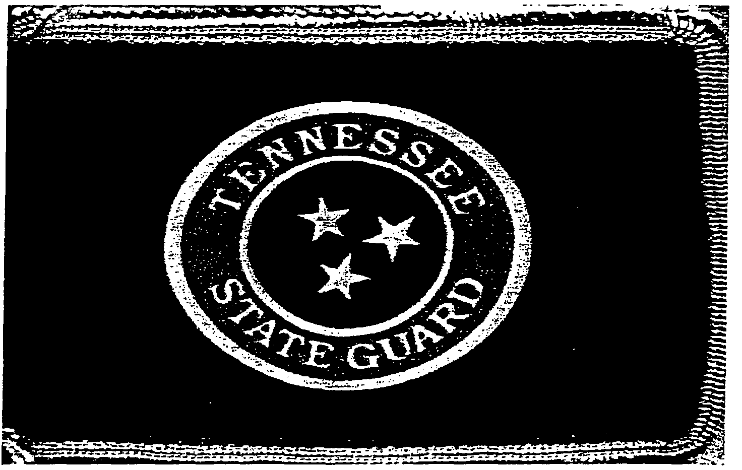IV. Pledge of Allegiance
Honors to the flag during the Pledge of Allegiance are similar to those rendered during
the playing of the National Anthem or "To the Colors."
- Military Formations or Ceremonies. You do not recite the Pledge of Allegiance while in military formation.
- Outdoors. When in military uniform, you stand at attention, race the flag, remain silent and salute.
- Indoors. When in military uniform, stand at attention, race the flag, but do not salute. You may recite the pledge indoors.
- Civilian Dress. When in civilian clothes (indoors or outdoors) you should stand at attention, face the flag, and recite the Pledge of Allegiance while holding your right hand over your heart. (Men should remove headdress and hold with right hand over their heart.)

V. Parades

In military uniform, you salute the flag as it passes in front of you. In civilian attire, come to attention until the flag passes.
VI. Foreign Flags
When you are visiting in a foreign country, you must show the same respect to the host country's flag and national anthem that you show to your own. The same is true when another country's national anthem is played during formal ceremonies in the United States.

MILITARY CUSTOMS & COURTESIES

Your decision to join the Tennessee State Guard (TNSG) reflects a dedication and commitment to support this volunteer military service organization. As a member of the Military, Department of the State of Tennessee, you are expected to follow the traditions,
standards, customs and courtesies agreed and accepted by the United States Army and the
Tennessee State Guard. These apply to all of us and reflect our pride and professionalism
as members of the Tennessee State Guard.

- Customs and Courtesies

Military customs and courtesies are proven traditions that explain what should and should not be done. They are acts of respect and courtesy in dealing with other people. They have evolved as a result of the need for order, as well as the mutual respect and sense of fraternity that exists among military personnel. The Tennessee State Guard shares in that tradition.

II. Saluting
It is a courtesy exchanged between members of the Tennessee State Guard when in military uniform as both a greeting and a symbol of mutual respect. As such, it is never inappropriate to salute another individual. The basic rules regarding saluting for TNSG members are:
- You salute when in military uniform.
- You salute the President of the United States, all Medal of Honor recipients, and commissioned officers and warrant officers of the Armed Forces who are senior in rank to you.
- You do not salute when indoors unless you are formally reporting to an officer senior ill rank to you.
- You salute when outdoors unless:
- You are carrying articles (or a heavy object) in both hands, which cannot be transferred to the left hand, or another legitimate reason such as injury, and so forth. In this case, an oral greeting should be exchanged, such as "Good Morning, Sir or Ma'am." If you are the lower ranking individual and the one you are approaching is higher in rank but whose arms are incapacitated, you will still salute.
- You are in a designated' covered" or "no salute" area, (aircraft marshalling areas and flight-lines are "no salute" areas).
- You are a member of a military formation or a work detail (only the senior member of the formation or detail salutes).
- You are attending a public gathering such as a sports event.
(5) When on a military installation, you salute officers in government cars if the car has a flag or metal standard that identifies the rank of the occupant (usually general officers and military wing or base commanders).
Respect for Retirees. Military retirees are treated with the same respect and courtesies as active duty members. By public law, they have earned and are entitled to enjoy certain US. Government benefits, rights, and privileges. One of these rights is that military members in a retired status are entitled to tie addressed, both in written and verbal communications, by their retired rank.
Respect for Authority. As a general rule highest ranking personnel enter an aircraft or
automobile last and leave first. Junior ranking personnel will walk to the left of seniors.
Unless otherwise authorized, subordinates will stand in the presence of senior officer
personnel. When senior personnel enter a room, subordinates will stand up unless a person of higher rank is already in the room. In the military, a senior in rank may address
a subordinate by his or her first name; however, it is inappropriate for a subordinate
to communicate in such an informal manner. Similar respect should he shown for
grades in the Tennessee State Guard.
III. Titles of Address
All military personnel are addressed by their title. Officers are addressed by the title appropriate to their rank (that is-, Captain, Major, General, and so forth) or use "Sir' or "Ma' am." Medical, dental, and veterinary officers are often addressed as Doctor;' chaplains are usually addressed as "Chaplain" or "Father," if appropriate. Titles of address for Army enlisted and officer personnel and TNSG personnel who choose to serve in these grades are seen in the chart below:

Title Term of Address

(Enlisted)
Command Sergeant Major
Sergeant Major
Master Sergeant
Sergeant First Class
Staff Sergeant
Sergeant
Corporal
Private First Class
Private

Sergeant Major or Sergeant
Sergeant Major or Sergeant
Master Sergeant or Sergeant
Sergeant
Sergeant
Sergeant
Corporal
Private
Private

(Officers)
General
Lieutenant General
Major General
Brigadier General
Colonel
Lieutenant Colonel
Major
Captain
First Lieutenant
Second Lieutenant

Warrant Officers (WO 1)
Warrant Officers (CWO 2 - 5)

General
General
General
General
Colonel
Colonel
Major
Captain
Lieutenant
Lieutenant

"Mr.
"Mr." Or "Chief"

RANK & INSIGNIA (Officer)*

The following section includes the insignia of rank worn by the United States Army and the personnel of the Tennessee State Guard. It is imperative that each member learn these symbols and be able to identify them by sight. This will insure that the proper respect and protocols will be observed at all times and with military professionalism.

The charts below are broken into two (2) columns, the first will be the grade, and the second the rank insignia that corresponds to that rank and grade. Officer ranks and grade are shown in the first set of charts, followed by the enlisted ranks and grades.

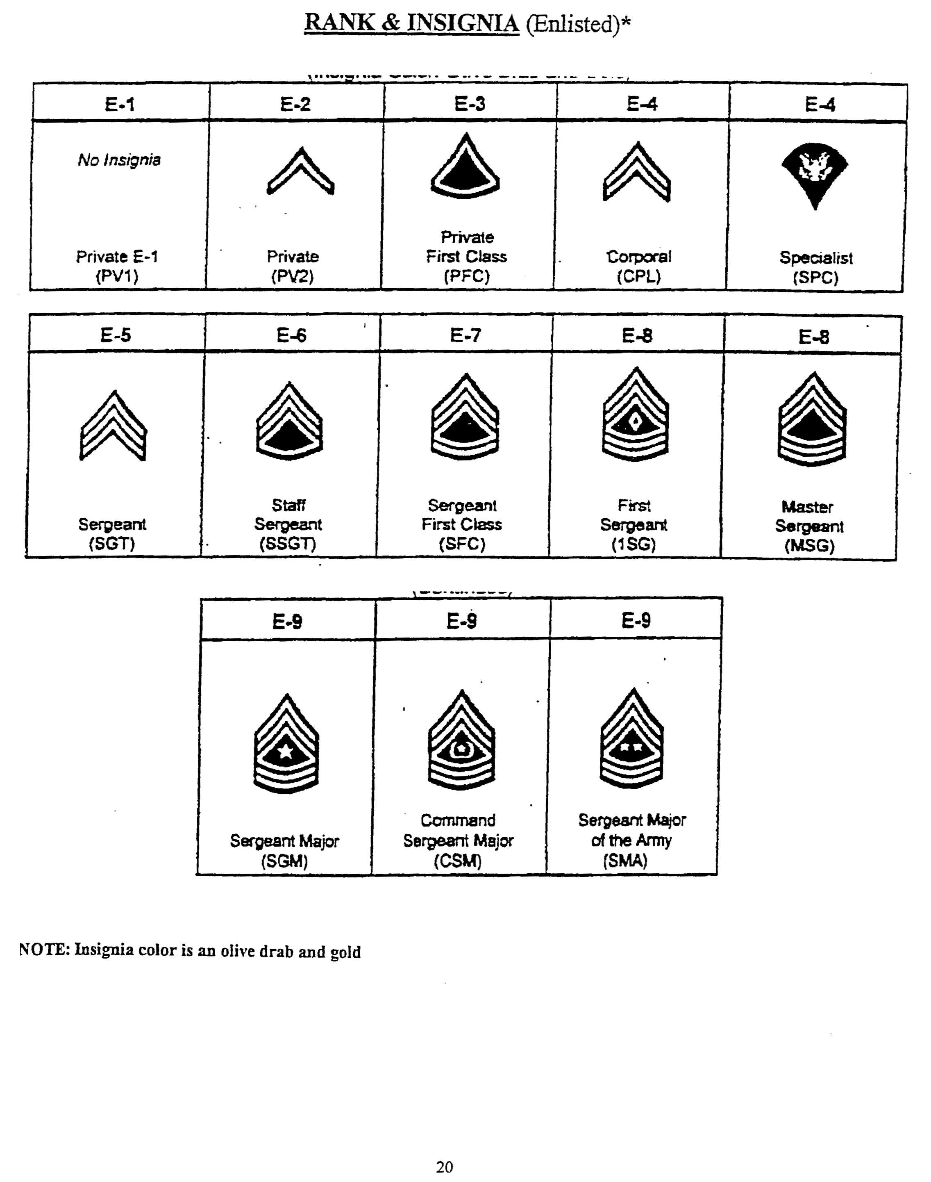
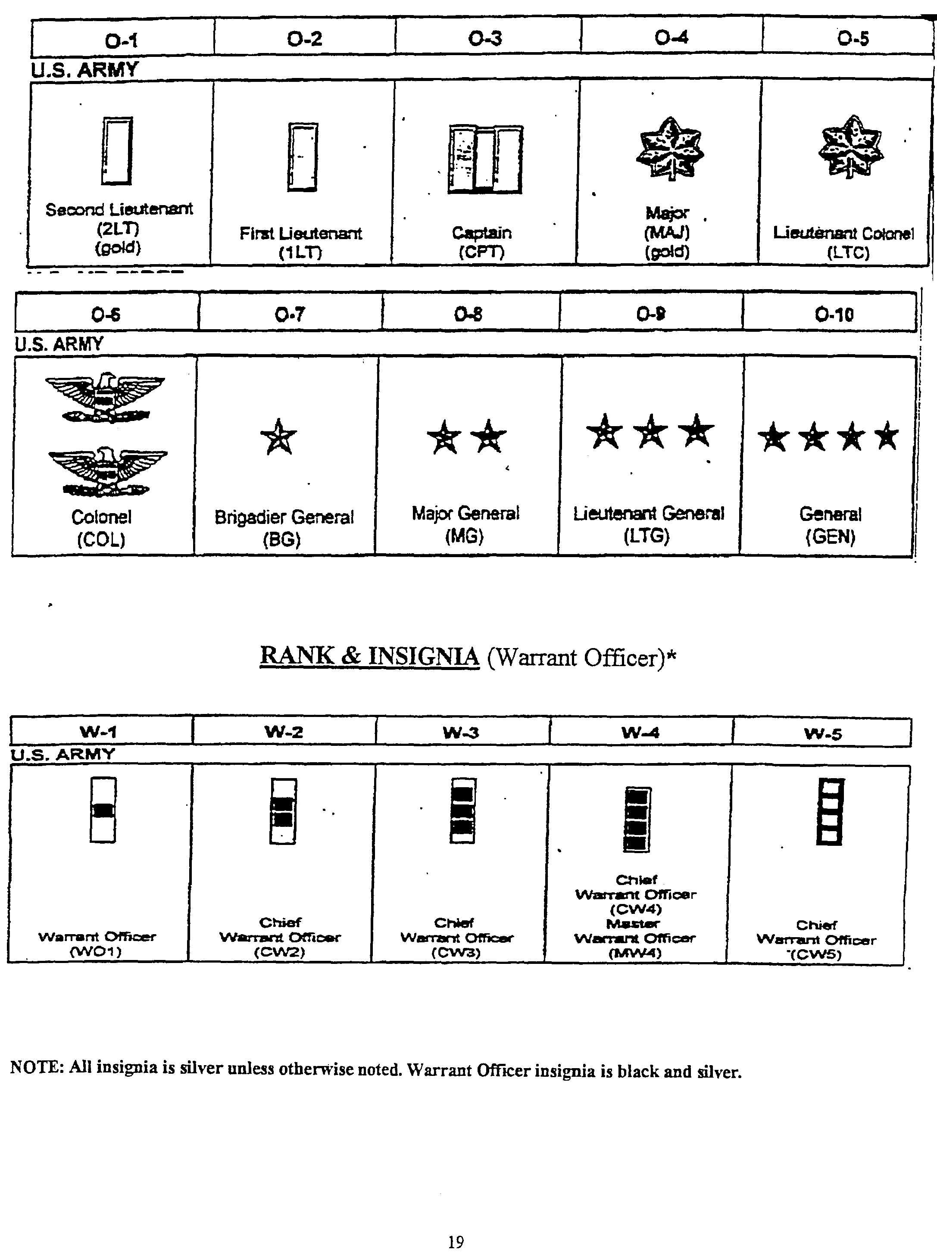

PROMOTIONS & AWARDS
Promotions
a. Promotions are made under the provisions of TNSG.
b. TNSG members may be promoted to the next higher grade provided that
a. a) vacancy requiring the higher grade exists b) the individual being recommended has met the professional educational qualifications prescribed for the higher grade; c) the tune in current grade requirements have been met; and d) the manner of past performance indicates potential for successful service in the higher grade.
c. Officer promotions are made by the Adjutant General, acting for the Governor upon recommendation by the Commanding General, TNSG. The Commanding General, TNSG may promote all enlisted personne1.
d. Promotions are official only upon announcement in orders published by the (G-I HQ TNSG. Individuals will not wear insignia of the higher rank until written orders have been received.
Professional Development

All TNSG soldiers are expected to pursue professional development studies appropriate to their grade and position. These studies are in addition to other TNSG training and operational responsibilities. Successful performance of duty and promotion is dependent upon having technically competent educationally qualified soldiers. The TNSG offers a complete program of Professional Development educational courses designed to provide the Knowledge to ensure excellence of service and to compete for promotions. These courses are not easy. They, are increasingly difficult and demand dedication, study, critical thinking and the deelopment of new skills and the assimilation of new knowledge. The ultimate personal reward is pride of accomplishment that comes from seeing the task through to completion and the knowledge that you have met and mastered the challenge to be the best that you can be.
Awards
The Military Department of Tennessee and the TNSG have established a number of awards to recognize both valorous and meritorious service. TNSG soldiers are eligible for award of both MDOTN and TNSG awards. supervisors at all levels are encouraged to recommend TNSG personnel for recognition of deserving acts and service. Descriptions of thy various awards, criteria for each award, and recommendation procedures are contained in TNSG regulations and in MDOTN regulations for state awards.
Training

Absent an emergency, the principal activity of the TNSG is training. It is the duty of each soldier to prepare himself, those under his supervision, and his unit to perform the missions that may be assigned. This requires planning. preparation, and devotion of the time required to ensure that training conducted within the unit is timely, focused on the mission, complete and accurate. We ask our soldiers to donate their time to prepare and serve the state. It is vitally important that all TNSG soldiers maximize that use of that time with well planned, meaningful training designed to prepare the TNSG to perform its operational missions. The Commanding Generals' training guidance is published annually to guide and coordinate training activities.
Rights and Benefits
As a member of the Tennessee State Guard, you are entitled to those rights and benefits as may be provided under the provisions of Tennessee law. It is command policy to continuously improve the benefits for service to the state. As a citizen, you are encouraged to exercise you influence with your elected representatives to strengthen and further improve the protections and benefits available from the state. Service in the TNSG does not confer any federal rights or benefits similar to those which are available to members of the National Guard or the Active Components. This includes access to military installations and activities.
TNSG Identification Cards
The TNSG Identification Card (DOD Form -TNSG) is issued to members of the TNSG to identify them as members of the force. It provides identification only. It does not grant access to federal military installations or activities. It does not confer any benefits The TNSG Identification Card is state property and must be returned upon termination of membership. The TNSG does not issue Identification cards to retired or former members of the TNSG.
CONDUCT
expected

The Tennessee State Guard has a very important mission and you, as a member of the
TNSG, have similar responsibilities for carrying out your mission. You are responsible
for carrying out orders, performing specific tasks related to your duties, and living up to
the high standards of tile TNSG. As a member of the TNSG, you are a representative of
the Governor, the Adjutant General, and the State of Tennessee. When dealing with the
public always be polite and professional. Your service as a member of the TNSG does
not confirm any special status on you. You have been granted a special trust by the state.
By virtue of that trust, you are expected to conduct yourself professionally, with dignity, and humility. Yon are not be better than your fellow citizens, merely different as you have undertaken the responsibility to serve them. Remember always to perform your duties so as not be bring embarrassment on yourself, your unit or "your fellow TNSG soldiers. The best guide for your conduct is to observe the Golden Rule "DO unto others as YOU would have them do unto you. "
You are also held accountable for your actions, both in the performance of your duties and in your personal conduct. If you are a supervisor, you have the responsibility to make sure your subordinates meet the expected standards. You must hold your subordinates accountable and take appropriate corrective actions when they do not fulfill their responsibilities. TNSG standards of conduct apply both on and oft duty, in your personal behavior, in your treatment of others, and in both military and civilian environments.
- Public displays of affection, such as hand-holding, embracing, or walking arm-in-arm are inappropriate actions for members in any TNSG uniform. Indiscriminate displays of affection. in public detract from the professional image the Tennessee State Guard intends to project.
- You may not use government facilities or equipment for other than officially approved activities.
- You may not gamble or bet while on government-owned-or-leased property or while on duty, unless specifically authorized.
- You may not engage in any conduct that is illegal, dishonest, or otherwise brings discredit on the Tennessee State Guard.

Possession and Use of Weapons
Possession and use of firearms and other offensive weapons while participating in TNSG activities is "prohibited. Prohibited weapons include firearms of any type, explosives. chemical defense sprays, martial arts Items, edged weapons other than pocket or hunting knives with standard length blades.
Tennessee State Guard Ethics
As a member of the Tennessee State Guard you must practice the highest standards of behavior obedience, and loyalty not only' in your job but in your relationship with other people. our code of ethics must be such that your behavior and motives do not create even the appearance of impropriety. Your commitment to integrity will lead the way for others to follow.
Job Performance
Job performance standards include what you do how much you do, and how well you accomplish your duties. Your primary. responsibility is to do your part to accomplish the mission. But accomplishing the mission requires more than Just technical proficiency. You also must be a good team member. You must be responsive and do what you are told quickly and efficiently. You must be dependable and responsible for your actions so supervisors do not have to constantly monitor or follow up on your activities. Quality and quantity of work are both important since they are the primary measures of your efficiency and productivity. Your conduct and performance on the job must he guided by a sense of loyalty to both supervisors and co-workers, consistent with the safe and proper fulfillment of regulations, directives, technical orders, and other lawful orders.
Drug Abuse
The illegal or improper use of drugs including marijuana, is absolutely incompatible with Tennessee State Guard standards of behavior, performance, and discipline necessary for accomplishing the mission and will not be tolerated. Drug abuse can seriously damage your physical and mental health, jeopardize your safety and the safety of others. It can also result in your separation from the TNSG and legal action taken by local authorities. You are responsible for, (1) reporting known or suspected incidents of drug abuse by others and (2) encouraging persons known to you to have an existing or potential drug abuse problem to seek assistance.
Alcohol Abuse
You have the responsibility to exercise good judgment in the use of alcohol. Your use of alcohol must not adversely affect your duty performance or your conduct on or off duty. Tennessee State Guard policy is to discourage alcohol abuse and alcoholism among its personnel and their dependents. Moderation should he encouraged for those persons choosing to drink and nondrinkers are not 12ressured or ostracized for choosing not to drink. Intoxication while engaged in a TNSG activity will not be tolerated. No alcohol will be served or consumed at drill meetings or training activities.
Equal Opportunity and Treatment
Tennessee State Guard standards of conduct require that you treat others with respect and dignity regardless of their race, color, religion, .age, national origin, or sex. The Tennessee State Guard does not tolerate arbitrary discrimination by act or inference, If you feel that you have been a victim of discrimination, you are encouraged to discuss the problem with your immediate supervisor or unit commander in an attempt to resolve it at the unit level.

APPEARANCE

Dress and Personal Appearance
You must comply with established dress and personal appearance standards outlined for the Tennessee State Guard. These standards consist of four elements: neatness cleanliness, safety, and image, and will be covered in more detail later in this manual The element requiring the most judgment is 'image." It is the most important aspect of the TNSG appearance standards Since other people, both military and civilian, draw certain conclusions about you and the TNSG based upon what they see. When in uniform, you are expected to present a professional image. This includes such things as walking with hands out of pockets. ensuring all buttons are buttoned, and maintaining certain grooming standards. -Your appearance must instill confidence and leave no doubt that TNSG personnel respect and live a common standard and are responsive to order and discipline. TNSG appearance standards are designed to reflect a moderate image and to exclude the extreme, the unusual, the fad. The standards are influenced to some degree by tradition and reflect the image the, TNSG intends to project to the public.
Personal Grooming
Although you have the right within established limits, to express your individuality through your appearance, the Tennessee State Guard has defined what is and what is not an acceptable, professional image for TNSG members. Except for minor variations based on sex differences all TNSG personnel must comply with the same personal grooming standards outlined in this manual. Supervisors nave the responsibility to determine compliance with the letter and intent of these standards and to correct the obvious violations, regardless of whether the situation identified is clearly written in the regulation.
Uniforms
A very important part of the image you project and the impression you create is how you wear your uniform. As with other personal appearance standards the Tennessee State Guard emphasizes a 'neat, clean, professional image. Your uniform is your personal property and it is your responsibility to keep it clean, pressed, and .in good repair. You are also responsible for knowing the authorized uniform combinations and the correct placement of ribbons, insignia, and other uniform items. Here are some general rules you should remember:
a. You must wear the appropriate uniform while performing your Tennessee State Guard duties.
b. You may wear only authorized uniform combinations, you may not mix uniform items or wear distinctive uniform items with civilian clothes. Distinctive uniform items are those items that are, unique to the uniform. They include grade insignia, ribbons, cap devices, and buttons with Tennessee State Guard emblems).
c. Outdoors: You are required to wear a hat or other headgear as authorized for the uniform combination. EXCEPTION: Hats are not required in designated 'no hat' areas.
d. Indoors: You will not wear a hat indoors. EXCEPTION: Individuals performing Color Guard duties do not remove headgear.
e. Members who choose to wear a military uniform when traveling by commercial means (other than to and from local TNSG activities) will wear the service dress (Class A) uniform or green short or long sleeve shirt/blouse with tie/tab. Authorized outer garments are the all-weather coat, overcoat, raincoat or jacket.
f. If you wear your uniform to civilian social functions you must wear the service
dress uniform, or mess dress uniform, or uniform that parallels the civilian dress for the occasion, that is, coat and tie. You may not wear BDU's to civilian functions.

In foreign countries
If you are a visitor in a foreign country, you will not wear a Tennessee State Guard
uniform.
Physical Fitness
You are responsible for keeping yourself in good physical condition and maintaining your weight within good health standards. This is important to both the Tennessee State Guard and you. Good physical condition and proper weight will help you fulfill your responsibility with vigor, alertness and provide you the .energy and capacity to respond to emergency situations as well as pursue leisure time activities. By maintaining a lean and fit appearance you also project the image expected of all TNSG personnel as a member of the Military Department of Tennessee. Command and supefV1sory involvement are integral parts of ensuring compliance with the fitness and weight programs.
g. It is important that you wear your uniform properly when on base however your appearance in uniform off base can be even more important. Members will not wear BDUs to off-base business establishments if they intend to do extended shopping, dining, socializing or take part ill any entertainment. To the general public you represent the Tennessee State Guard and the United States Army. You must ensure that your appearance creates a positive, favorable impression.
h. TNSG members will not wear the uniform or any part of the uniform:
- At a meeting or demonstration by, or sponsored by an organization, association movement, or group that the Attorney General of the United States has designated as Totalitarian, Fascist, Communist, or subversive.
- Advocates or approves acts of force or violence to deny others their rights under the Constitution of the United States.
- Seeks to change the United States government by unconstitutional means.
- When participating in activities such as public speeches, interviews, picket lines, marches, or rallies; or in any' public demonstration (including civil rights demonstrations) not approved by the Adjutant General and the Military Department Tennessee, wearing of the uniform may imply sanction of the cause for which the demonstration or activity is conducted.
- When furthering private employment or commercial interests, if official sponsorship, might be inferred.
- When engaged in private employment.
- When it would discredit the Armed Forces.
- At any public meeting, demonstration, march. rally or interview if the
purpose may be to advocate, express, or approve opposition to the Armed Forces of the United States

WEARING THE UNIFORM

Personal Appearance

a. Haircuts

- Males: The hair on the top of the head will be neatly groomed. Length and or bulk will not be excessive or present a ragged appearance. When combed hair will not fall over the ears, the eyebrows. or touch the collar and will not interfere with the wear of standard headgear.
- (2) Females: Hair will be neatly groomed not present a ragged or unkempt appearance, nor interfere with the wear of standard headgear. Hair win not extend past the bottom edge of the collar, nor be so short as to present an unfeminine appearance. Accessories will be natural or transparent in color and placed so as to be inconspicuous.
- (3) Shaving: The face will be clean shaven, except that neat mustaches are permitted. If worn, mustaches will be kept trimmed, tapered and tidy. No portion may extend beyond or below the comers of the mouth. Handlebar mustaches, goatees, beards, unshaven hair below the lower lip are not authorized.
- Sideburns: Sideburns must be neatly trimmed. The base will not be flared and will terminate with a clean-shaven horizontal line. Sideburns will not extend downward below the exterior opening of the ear.
- Make-up: Female personnel are authorized to wear makeup and nail polish as long as It presents a neat conservative appearance and complements the uniform.
Uniforms
The standard uniform for TNSG personnel is the Battle Dress Uniform (BDU).
a. Army Class B uniforms may be worn when authorized by commanders. Typical occasions for wear are when conducting recruiting duties, representing the TNSG at public events, or for social occasions (unit parties). AR670-1 prescribes composition and manner of wear. Distinctive insignia including the red TNSG name tag and the "TN' insignia placed on the shoulder marks of officers are required.
b. The Army Class A uniform will only be worn when specific approval has been granted by HQ, TNSG. Distinctive insignia including the red TNSG name tag, TNSG shoulder patch, and "TN" buttons and "TN" and crossed bayonet lapel insignia are required. AR670-1 prescribes composition and manner of wear.
c. TNSG Uniforms will be worn as follows:
- During TNSG training activities, approved operations or when representing the TNSG at public gatherings.
- Essential stops at commercial establishments including service stations, grocery stores, cleaners, banks and restaurants incident to duty or travel to or from are authorized when, wearing the BDU uniform.
- Stops at recreational facilities such as parks, pools, theaters, bars, clubs and the like are prohibited while wearing the BDU uniform

RECRUITING

All Tennessee State Guardsmen are encouraged to share in the responsibility and activity of recruiting. No other single resource for drawing individuals into the TNSG is as effective as "word of mouth" recruiting. Each of us wieldssome degree of influence upon our family and friends and this influence can be utilized to bring others into the TNSG. As an incentive to this end, any guardsman who personally recruits a total of five (5) individuals into the TNSG is eligible for the TNSG recruiting ribbon. This award is issued following the successful swearing of your five recruits. A gold star is awarded and attached to this ribbon for each additional five (5) persons you have personally recruited into TNSG service.

GENERAL ORDERS
You might want to get a head start on Basic and memorize
your general orders now. General orders are the same no matter where you're stationed in the Army.
1
I will guard everything within the limits of my post and quit my post only when properly relieved.
2
I will obey my special orders and perform all my duties in a military manner.

I will report violations of my special orders, emergency cies, and anything not covered in my instructions, to the commander of the relief.
3

SPECIAL ORDERS
Special orders are established by the commanding officer and differ from post to post depending on the nature of the area you're guarding.

